**Lesson 11: Data Representations**

2

Mountain

City and Abroad

9

4

7

22

C

D

E

A

B

**Do Now:** Answer the questions below as best as you can. Be ready to explain how you used the graph to answer.

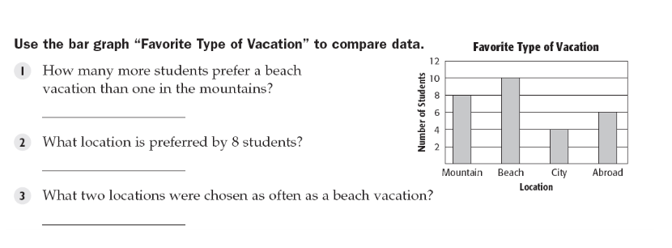

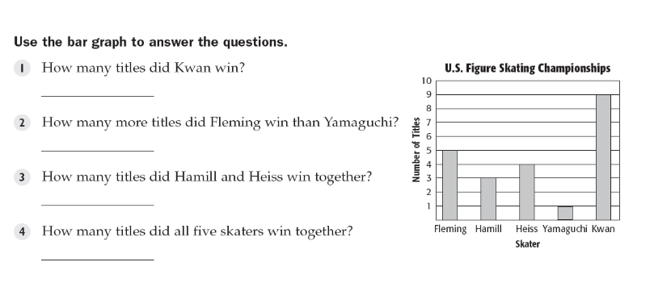

**Key Vocabulary:**

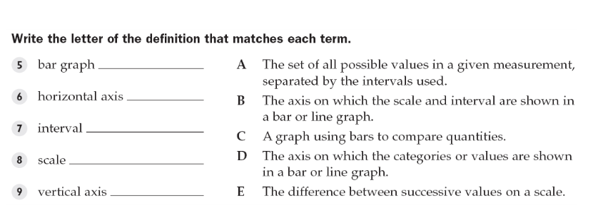

A **scatter plot** is a graph that shows the relationship between two sets of data. In a scatter plot, two

sets of data are graphed as ordered pairs on a coordinate system. A scatter plot may show a pattern

or relationship of the data. The relation may be positive or negative, or there may be no relationship.

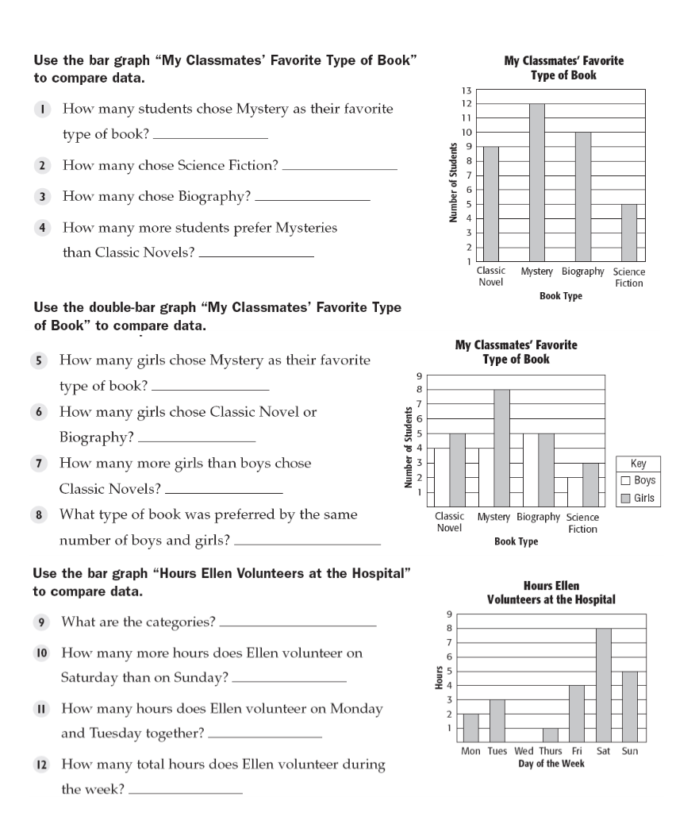

12

5

10

3

8

10

1

Biography

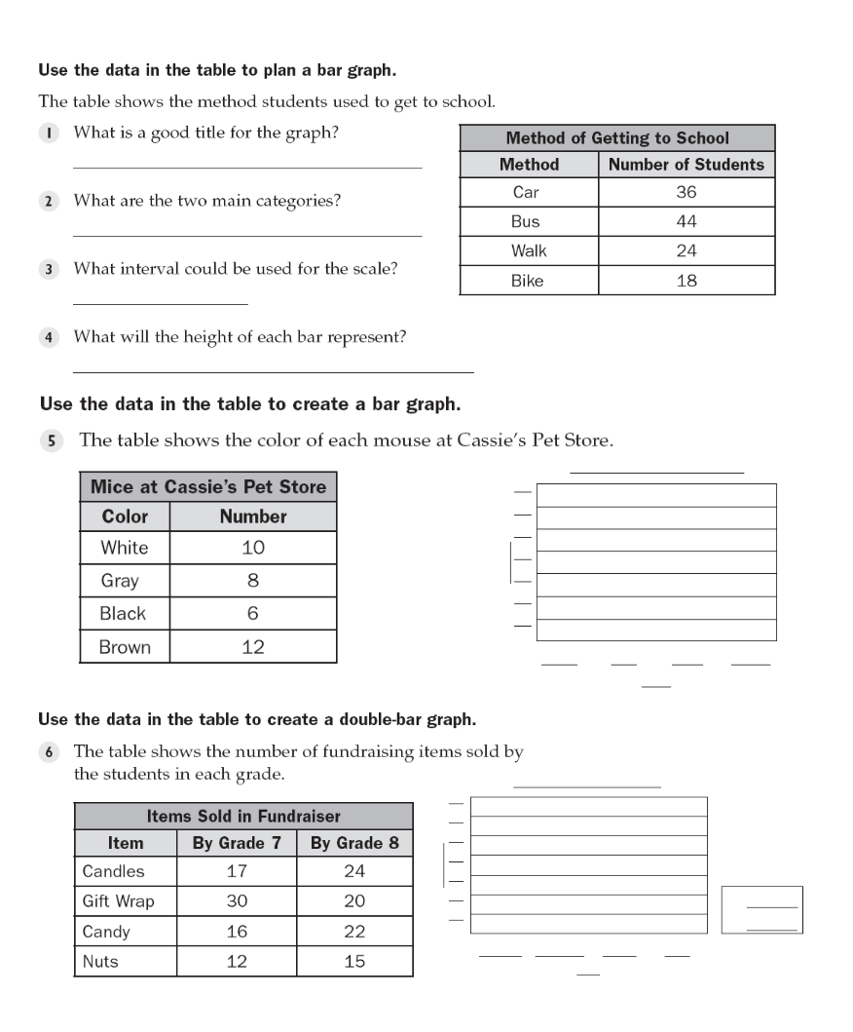

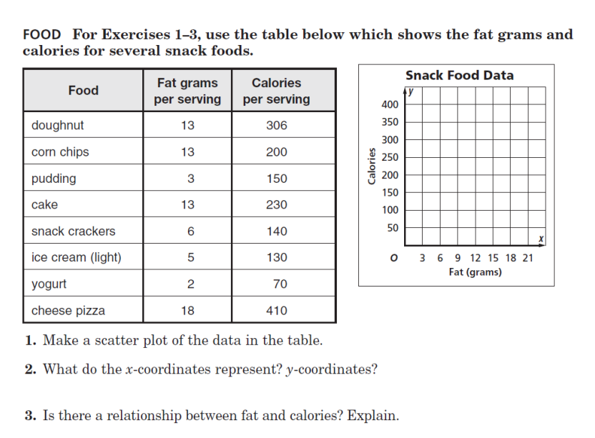

x-coordinates represent fat in grams. y-coordinates represent calories

positive correlation

**Structured/Guided Practice:**

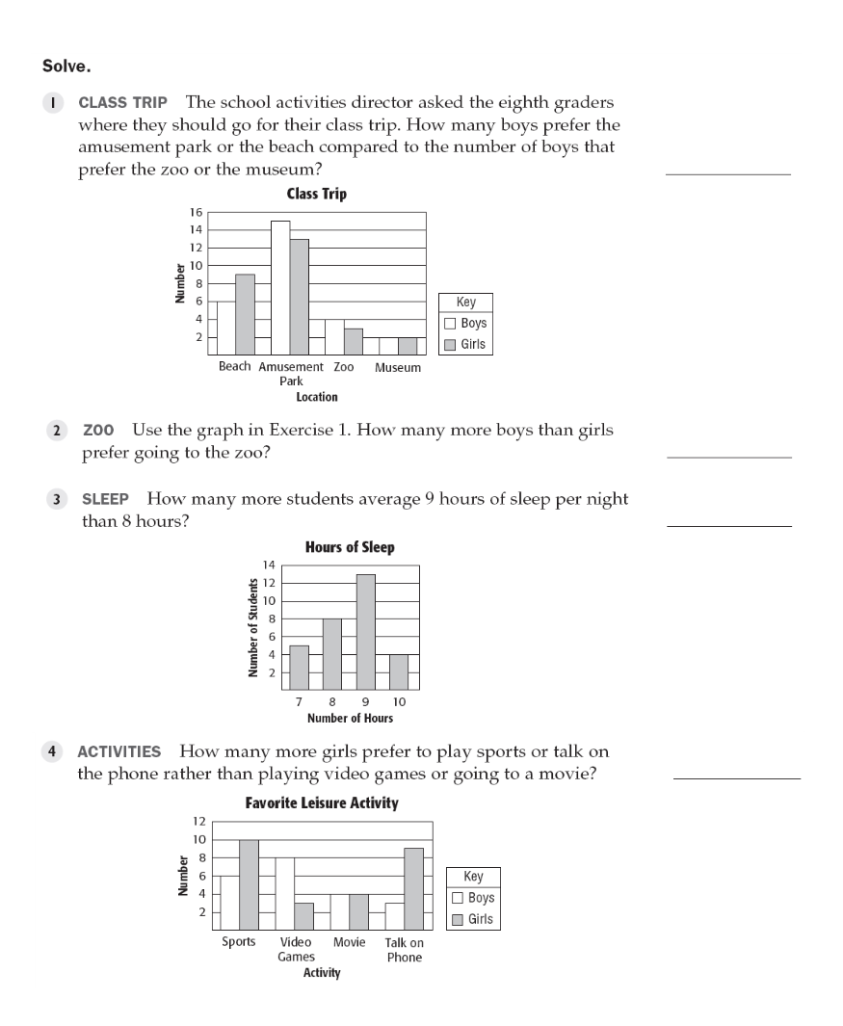

15

1

5

12

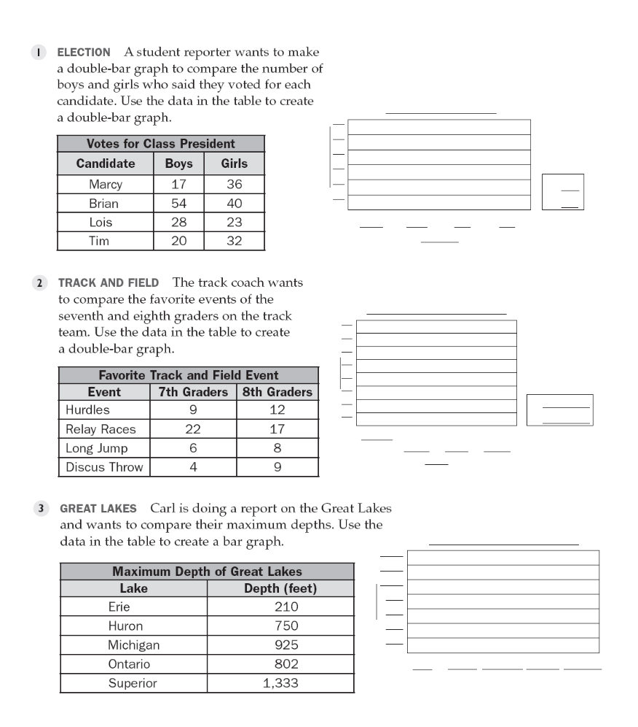

**Independent Practice:**

19

4

21

C

54

1

35

5

22

Merry-go-round

6

